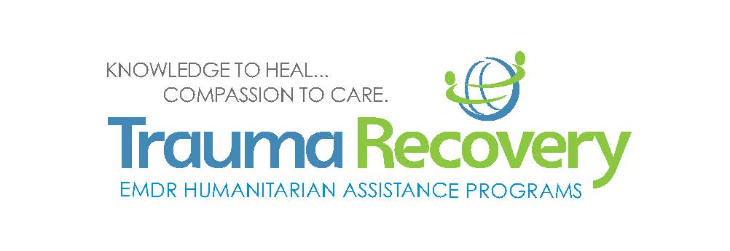
Start a Trauma Recovery Network Association in Your Community
in 30 Days or Less!
Trauma Recovery/HAP Mission: To increase the capacity for effective treatment of psychological trauma in under-served communities anywhere in the world.
Trauma Recovery Network Purposes: to assist in times of emergency with pro bono services and to address ongoing circumstances contributing to trauma in their local communities; to network with the local emergency management system and with other groups within the TRN to share informational resources and lessons learned; to engage in outreach to both the general public and community leaders on the nature and treatment of psychological stress.

1. Form an initial Steering Committee of three people who are signed up as TR/HAP volunteers to lead the process. All individuals must have completed an EMDRIA authorized Basic Training in EMDR therapy; certification in EMDR therapy is not required.
2. Choose your association’s Coordinator and identify your EMDRIA Approved Consultant.
3. Send the following information to the Trauma Recovery/HAP Program and Community Development Director.
- Names of the TRN Association Members – all TRN Members must be registered as Trauma Recovery/HAP volunteers and must sign a TRN Member Agreement. This agreement can be found in the member’s volunteer account, on line at emdrhap.org.
- Names, telephone numbers and email addresses for the TRN Association coordinator and the EMDRIA approved consultant.
- The requested name for the association which should describe the specific area in which you wish to be active, e.g. TRN Association of Tulsa, TRN Association of _____ County.
- A brief statement of anticipated activities in furtherance of the Mission and Model to deliver the Purposes.
4. Once the information is received and the name accepted or modified and assigned, the association will be added to the Trauma Recovery Network database and will be listed on line in the TRN section at emdrhap.org.
5. The Program and Community Development Director signs the TRN Association Agreement and you are off and running.
Please review the obligations of
TRN Members and TRN Associations provided below:
TRN Member Obligations
1. Conduct activities in accordance with the standards set by the EMDR community.
2. Maintain and comply with professional practice insurance, licensing requirements and yearly reaffirmation of the Policy and Procedures statement.
3. Maintain current information in the online volunteer account.
4. Provide any pro bono services to individuals in accordance with the TRN manual maintained by Trauma Recovery/HAP.
5. Not conduct personal business while acting as a TRN Member.
6. Conduct all activities as a TRN Member in furtherance of the Community focus and Model to deliver the Purposes and prohibits the promotion of commercial or private trainings.
7. Use TRN Member contact information, including email lists or accounts, only in furtherance of the Mission and to deliver the Purposes.

TRN Association Obligations
1. Conduct all activities in furtherance of the Community focus and to deliver the Purposes.
2. Provide from six to ten pro bono EMDR therapy sessions to TRN clients.
3. The TRN Coordinator will provide quarterly on line client data to the entered into the Trauma Recovery/HAP administrative system.
2. TRN Association Members have entered into a TRN Member Agreement and will maintain good standing.
3. Use all funds Trauma Recovery/HAP distributes in accordance with all terms and conditions on the use of such funds.
4. Use TRN Member contact information, including email lists or accounts, only in furtherance of the Mission and to deliver the Purposes.
5. Not discriminate in the provision of services or the management of TRN Members on any basis that is prohibited by law or Trauma Recovery/HAP policy.
6. Not endorse goods or services of third parties.
7. Not engage in activities that are intended to influence legislation or that endorse or oppose candidates for public office.

Trademark Provisions Applicable to Both
TRN Members and TRN Associations

Provided you comply with the terms and conditions of this license, Trauma Recovery/HAP grants you a limited, revocable, royalty-free, nonexclusive and non-transferable license to use the marks listed on Exhibit A (the “Licensed Marks”) in furtherance of Trauma Recovery/HAP’s mission. You shall use the Licensed Marks only in the form provided by Trauma Recovery/HAP and shall not modify the Licensed Marks except proportionately as to size. No Licensed Marks shall be combined with any other trademarks or service marks without the express, written permission of an authorized representative of Trauma Recovery/HAP. All uses of the Licensed Marks shall be pre-approved by Trauma Recovery/HAP. By becoming a TRN Member or Association, you acknowledge Trauma Recovery/HAP’s ownership of the Licensed Marks. You agree not to assert any ownership interest in the Licensed Marks nor take any action that would damage or diminish Trauma Recovery/HAP’s ownership of the Licensed Marks. You agree to inform Trauma Recovery/HAP of any unauthorized use of the Licensed Marks and to cooperate with Trauma Recovery/HAP in enforcing its trademark rights. Trauma Recovery/HAP shall have the right to control the nature and quality of all goods and services provided by you under the Licensed Marks, and you shall cooperate with Trauma Recovery/HAP in providing all information and documentation necessary for Trauma Recovery/HAP to exercise such control. Any and all goodwill in the Licensed Marks arising from your use of the Licensed Marks shall inure solely to the benefit of Trauma Recovery/HAP.

EXHIBIT A

U.S. Trademark Application No. 87816345
Mark: HAP (standard character)

U.S. Trademark Reg. No. 4840493
Mark: TRAUMA RECOVERY (stylized)

U.S. Trademark Reg. No. 5811325
Mark: TRAUMA RECOVERY (stylized)

U.S. Trademark Reg. No. 5563671
Mark: TRAUMA RECOVERY NETWORK (standard character)

U.S. Trademark Reg. No. 5544866
Mark: TRN (standard character)

U.S. Trademark Reg. No. 5729466
Mark: Globe-hugging people (stylized)

